**MODULE FOR ROBOTIC ARM**

Authors: Justin Cabacungan, Alexander Tang, Nick Ribeiro

**CONTENTS**

INTRODUCTION. . . . . . . . . . . 3

QUICK FACTS. . . . . . . . . . . . . 4

IMAGES. . . . . . . . . . . . . . . . . . 6

TUTORIAL. . . . . . . . . . . . . . . . 7

REFERENCES. . . . . . . . . . . . . . 8

**INTRODUCTION**

**QUICK FACTS**

* Canada Arm is a 17-metre-long**robotic arm**, and was extensively involved in the assembly of the orbiting laboratory.
* 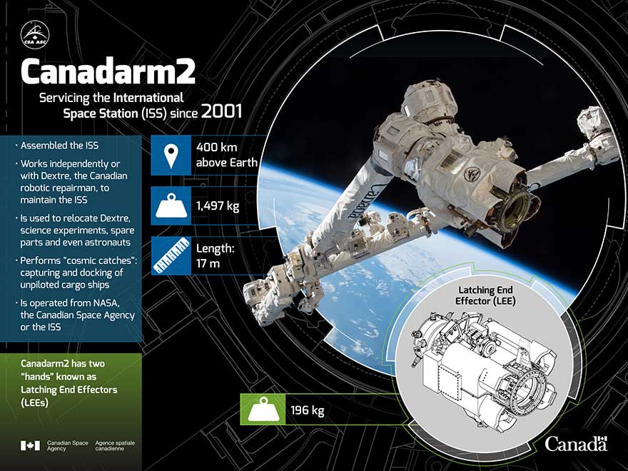Canada Arm’s specification, location, and functions:

Image source: Canadian Space Agency

* 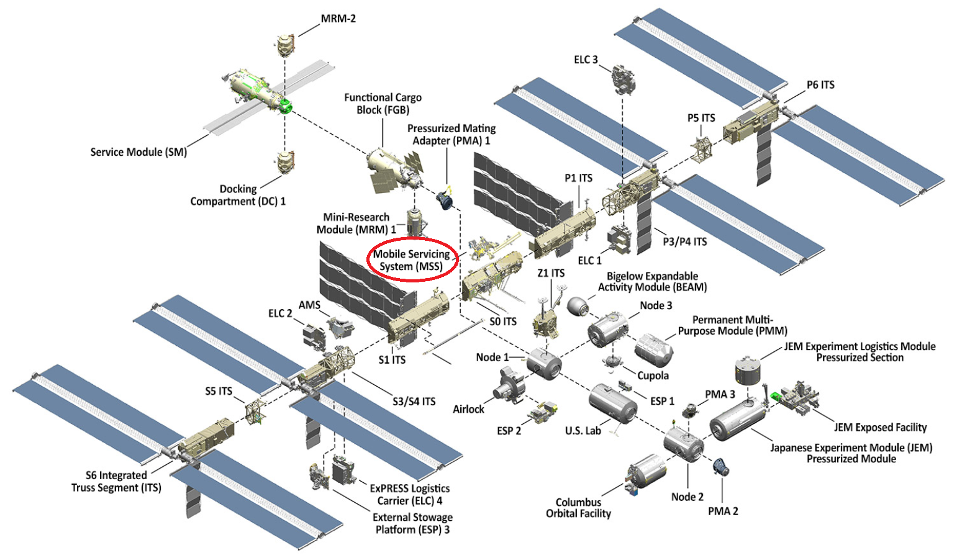Location of the robotic arm in the ISS (International Space Station) is in Mobile Service System

Image source: <https://www.nasa.gov/feature/facts-and-figures>

* Mission Overview of Canada Arm 2

**Technical Name:** Space Station Remote Manipulator System (SSRMS)

**Launch Date:** Canada Arm 2 was launched aboard Space Shuttle Endeavor on April. 19, 2001.

**Mission:** Assembling and maintaining the space station, and Capturing unpiloted resupply vehicles.

**Ownership:** Canadian Space Agency

**Built by:** MacDonald, Dettwiler, and Associates Ltd. in Brampton, Ontario

**Length:** 17 m

**Composition:** 19 Layers of high-strength carbon thermoplastic fibres.

**Degrees of Freedom:** Seven degrees of freedom, making it very similar to a human arm

Source: <http://www.asc-csa.gc.ca/eng/iss/canadarm2/data-sheet.asp>

* Along with Canadian astronaut Chris Hadfield, Canadarm2 was pictured on a coin, available in gold or silver, created in 2006 by the Royal Canadian Mint. The robotic arm was also featured on a 2011 stamp issued by Canada Post.

**IMAGES (WEBGL AND BLENDER)**

Images provided by: Nandu Vellal, and Nick Ribeiro

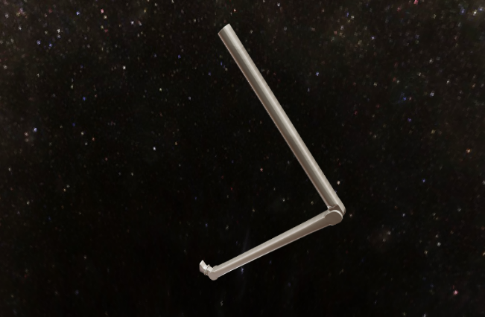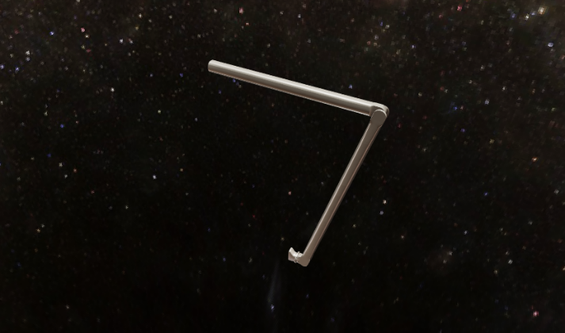

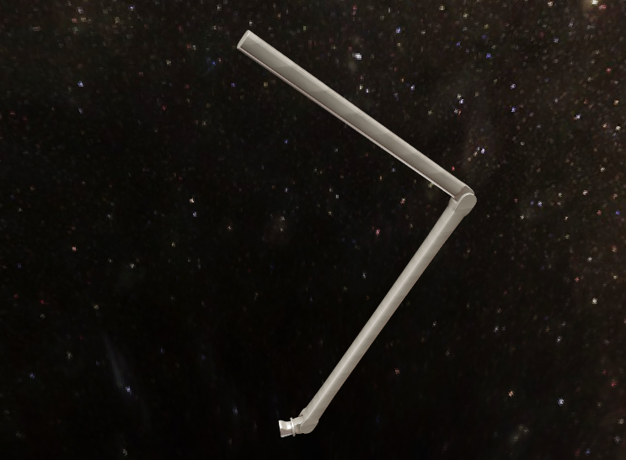

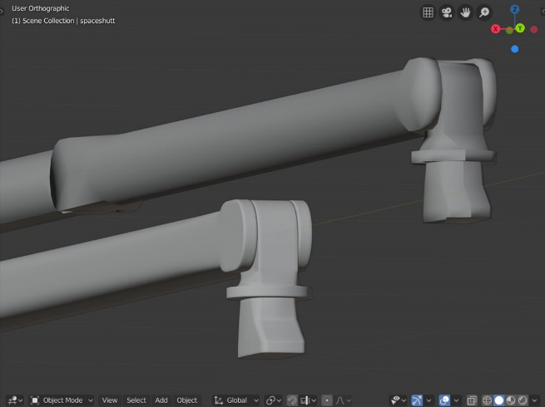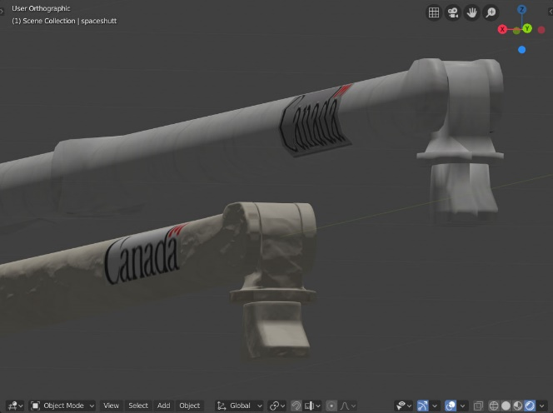

**TUTORIAL**

**GOAL:** Able to move materials from one area to another on the ISS (Microgravity Environment)

**CHALLENGES:**

* The complexity of operating an equipment in microgravity
* Capture and attach a satellite for the ISS
* Deploy a Satellite into orbit

**WHAT IS MICROGRAVITY?**

Microgravity is the condition in which people or objects appear to be weightless. The effects of microgravity can be seen when astronauts and objects float in space. Microgravity can be experienced in other ways, as well. "Micro-" means "very small," so microgravity refers to the condition where gravity seems to be very small.

**IS THERE GRAVITY ON SPACE?**

Gravity causes every object to pull every other object toward it. Some people think that there is no gravity in space. In fact, a small amount of gravity can be found everywhere in space. Gravity is what holds the moon in orbit around Earth. Gravity causes Earth to orbit the sun.

**STEP 1:**

**STEP 2:**

**STEP 3:**

**STEP 4:**

**STEP 5:**

**REFERENCES**

* <https://www.nasa.gov/>
* Start from Page 25 of the document: <https://www.nasa.gov/sites/default/files/atoms/files/np-2015-05-022-jsc-iss-guide-2015-update-111015-508c.pdf>
* <http://www.asc-csa.gc.ca/eng/iss/canadarm2/default.asp>
* <http://www.asc-csa.gc.ca/eng/Default.asp>
* <https://www.nasa.gov/audience/forstudents/5-8/features/nasa-knows/what-is-microgravity-58.html>